Install a few packages that are required.
source("http://bioconductor.org/biocLite.R")
#biocLite(ggplot2)
#biocLite(RColorBrewer)
#biocLite(cluster)
#biocLite(WGCNA)
#biocLite("metaMA")
#biocLite("lattice")
#biocLite("genefilter")
#biocLite("dplyr"")
#biocLite("pathview")
library(metaMA)
library(lattice)
library(genefilter)
library(edgeR)
library(ggplot2)
library(RColorBrewer)
library(cluster)
library(WGCNA)
## ==========================================================================
## *
## * Package WGCNA 1.51 loaded.
## *
## * Important note: It appears that your system supports multi-threading,
## * but it is not enabled within WGCNA in R.
## * To allow multi-threading within WGCNA with all available cores, use
## *
## * allowWGCNAThreads()
## *
## * within R. Use disableWGCNAThreads() to disable threading if necessary.
## * Alternatively, set the following environment variable on your system:
## *
## * ALLOW_WGCNA_THREADS=<number_of_processors>
## *
## * for example
## *
## * ALLOW_WGCNA_THREADS=4
## *
## * To set the environment variable in linux bash shell, type
## *
## * export ALLOW_WGCNA_THREADS=4
## *
## * before running R. Other operating systems or shells will
## * have a similar command to achieve the same aim.
## *
## ==========================================================================

Read in data
data <- read.table(file="https://raw.githubusercontent.com/ucdavis-bioinformatics-training/2017-June-RNA-Seq-Workshop/master/thursday/all_counts.txt", sep="\t", header=T, stringsAsFactors=F)
pdata <- read.table(file="https://raw.githubusercontent.com/ucdavis-bioinformatics-training/2017-June-RNA-Seq-Workshop/master/friday/Figures/pdata.txt", sep="\t", header=T, stringsAsFactors=F)
pdata$Cultivar <- factor(pdata$Cultivar, levels=c("C", "I5", "I8"))
pdata$TimePoint <- factor(pdata$TimePoint, levels=c("6", "9"))
head(pdata)
## Cultivar TimePoint
## C61 C 6
## C62 C 6
## C63 C 6
## C64 C 6
## C91 C 9
## C92 C 9

generate normalized counts (counts-per-million) using cpm() function
keep <- rowSums(cpm(data) > 1) > 1
counts <- data[keep,]
norm.counts <- cpm(counts)

generate MDS plot
group <- interaction(pdata$Cultivar, pdata$TimePoint)
labs <- colnames(norm.counts)
plotMDS(norm.counts, col=as.numeric(group), labels=labs, lwd=2, cex=0.7)
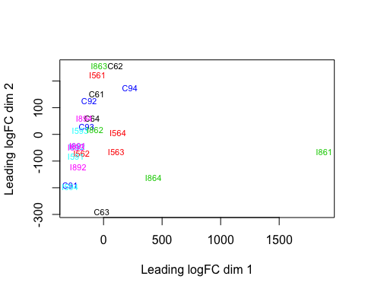

PCA plot
rv <- rowVars(norm.counts)
select <- order(rv, decreasing=TRUE)[seq_len(100)]
pca <- prcomp(t(norm.counts[select,]))
fac <- factor(apply(pdata[,c("Cultivar", "TimePoint")], 1, paste, collapse=":"))
colours <- brewer.pal(nlevels(fac), "Paired")
pcafig <- xyplot(PC2 ~ PC1, groups=fac, data=as.data.frame(pca$x), pch=16, cex=1, aspect="iso",
col=colours, main=draw.key(key=list(rect=list(col=colours), text=list(levels(fac)),
rep=FALSE)))
print(pcafig)
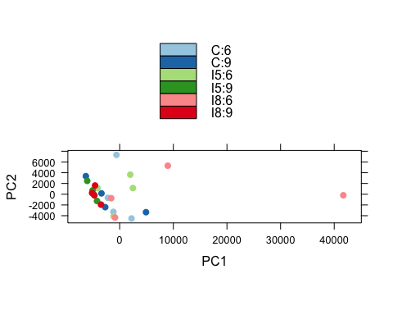
## Draw colour keys non-default way
pcafig <- xyplot(PC2 ~ PC1, groups=fac, data=as.data.frame(pca$x), pch=16, cex=1, aspect="iso",
col=colours, main=draw.key(key=list(rect=list(col=colours), text=list(levels(fac)),
rep=FALSE, columns=3)))
print(pcafig)
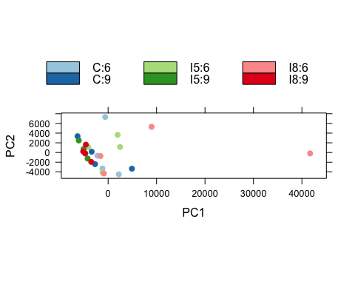

Clustering of samples
dist.matrix <- dist(t(norm.counts))
sampleTree <- hclust(dist.matrix)
colours <- data.frame(Cultivar=labels2colors(pdata$Cultivar), TimePoint=labels2colors(pdata$TimePoint))
plotDendroAndColors(sampleTree, colors=colours, groupLabels=c("Cultivar", "TimePoint"), colorHeight=0.1, autoColorHeight=FALSE)
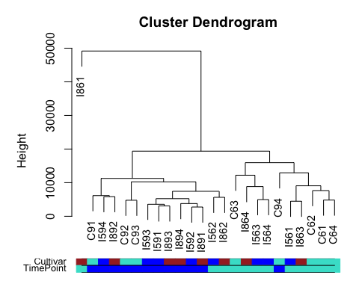

Visualize differential expression results by volcano plot
library(dplyr)
data <- read.table(file="https://raw.githubusercontent.com/ucdavis-bioinformatics-training/2017-June-RNA-Seq-Workshop/master/friday/Figures/I5_v_C_time6.txt", sep="\t", header=T, stringsAsFactors=F)
logFDR <- -log10(data$adj.P.Val)
## plot -log10(adj.P.Val) ~ logFC
plot(data$logFC, logFDR, xlab="log2(Fold-Change)", ylab="-log10FDR")
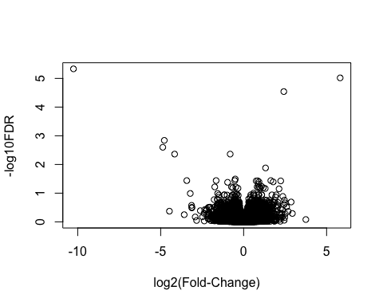
## label significant genes
data <- mutate(data, sig=ifelse(data$adj.P.Val<0.05, "FDR<0.05", "Not Significant"))
## Warning: package 'bindrcpp' was built under R version 3.2.5
## plot volcano with significant genes in red
p <- ggplot(data, aes(logFC, -log10(adj.P.Val))) + geom_point(aes(col=sig)) + scale_color_manual(values=c("red", "black"))
p
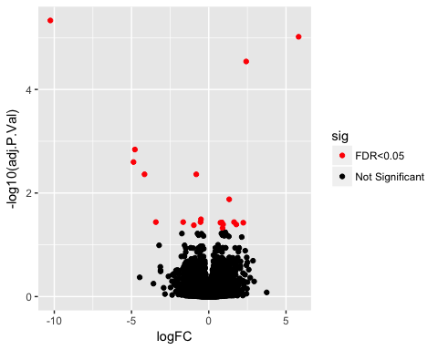
## add gene names to selected genes
p + geom_text(data=filter(data, adj.P.Val<0.001), aes(label=Gene))
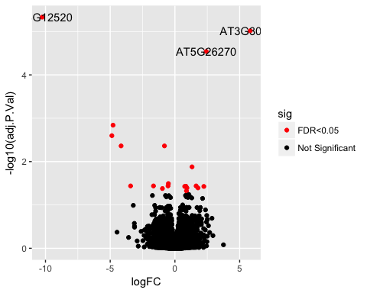
p + geom_text(data=data[order(data$adj.P.Val, decreasing=FALSE)[1:10],], aes(label=Gene))
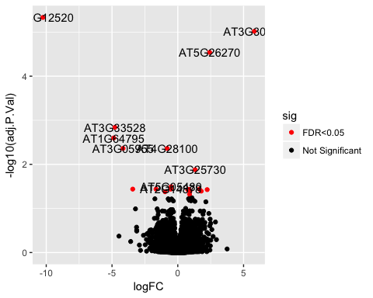
p + geom_text(data=data[order(data$adj.P.Val, decreasing=FALSE)[1:10],], aes(label=Gene)) + geom_vline(xintercept=c(-2,2), colour="black") + geom_hline(yintercept=1.3, colour="black")
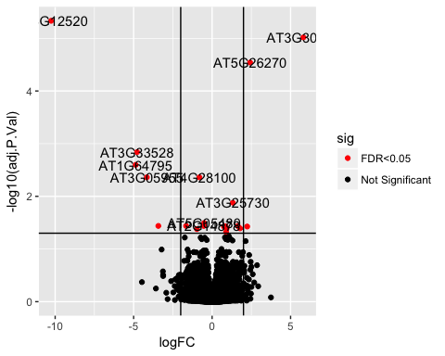

Heatmaps
library(devtools)
library(gplots)
slt <- order(rv, decreasing=TRUE)[seq_len(20)]
heatmap.2(norm.counts[slt,], col=heat.colors, trace="none", margin=c(3,7))
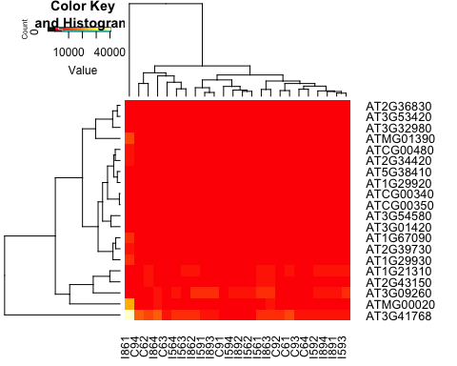
heatmap.2(norm.counts[slt,], col=heat.colors, trace="none", margin=c(3,6), cexRow=0.8, cexCol=0.8)
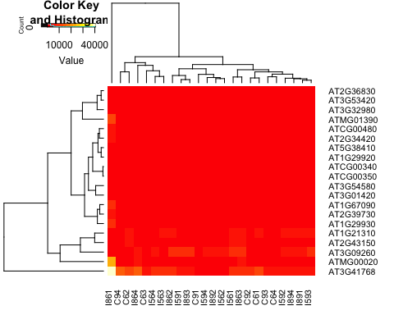
heatmap.2(norm.counts[slt,], col=heat.colors, trace="none", margin=c(3,7), cexRow=0.8, cexCol=0.8, ColSideColors=labels2colors(pdata$Cultivar))
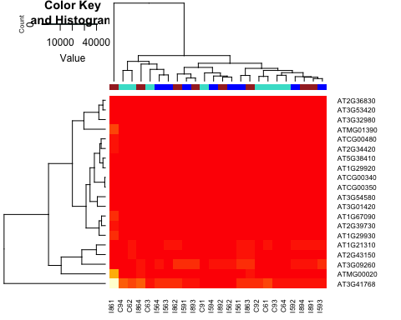
rowcols <- rep(brewer.pal(4, 'Set1'), each=5)
names(rowcols) <- rownames(norm.counts[slt,])
heatmap.2(norm.counts[slt,], col=heat.colors, trace="none", margin=c(3,7), cexRow=0.8, cexCol=0.8, ColSideColors=labels2colors(pdata$Cultivar), RowSideColors=rowcols)
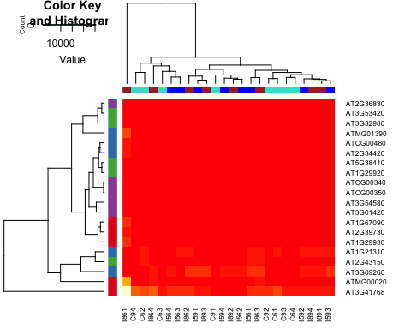

Heatmaps with multiple side bars using heatmap.3()
source_url("https://raw.githubusercontent.com/obigriffith/biostar-tutorials/master/Heatmaps/heatmap.3.R")
## SHA-1 hash of file is 015fc0457e61e3e93a903e69a24d96d2dac7b9fb
rlab <- t(rowcols)
rownames(rlab) <- "GeneType"
clab <- cbind(labels2colors(pdata$Cultivar), labels2colors(pdata$TimePoint))
colnames(clab) <- c("Cultivar", "TimePoint")
# The plot will be saved to a pdf file because of the size of the figure
pdf("test_heatmap3.pdf")
heatmap.3(norm.counts[slt,], col=heat.colors, trace="none", cexRow=0.8, cexCol=0.8, ColSideColors=clab, RowSideColors=rlab, ColSideColorsSize=2, RowSideColorsSize=2, margin=c(5,5))
dev.off()
## quartz_off_screen
## 2

select genes from the differential expression analysis results
# first, load in your differential expression analysis results
tmp <- read.table(file="https://raw.githubusercontent.com/ucdavis-bioinformatics-training/2017-June-RNA-Seq-Workshop/master/friday/Figures/I5_v_C_time6.txt", sep="\t", header=T, stringsAsFactors=F)
sel.genes <- tmp$Gene[1:10]
# then, match the names of your selected genes to the rownames of your counts table
index <- match(sel.genes, rownames(norm.counts))
# then, follow some steps from above to generate necessary colors and labels
rowcols <- rep(brewer.pal(5, 'Set1'), each=2)
names(rowcols) <- rownames(norm.counts[index,])
rlab <- t(rowcols)
rownames(rlab) <- "GeneType"
clab <- cbind(labels2colors(pdata$Cultivar), labels2colors(pdata$TimePoint))
colnames(clab) <- c("Cultivar", "TimePoint")

Using log transformed data.
log.counts <- cpm(counts, log=TRUE)
rv <- rowVars(log.counts)
slt <- order(rv, decreasing=TRUE)[seq_len(20)]
# use non-default color scheme
mypalette <- brewer.pal(11, "RdYlBu")
morecols <- colorRampPalette(mypalette)
heatmap.2(log.counts[slt,], col=morecols, trace="none", margin=c(3,7))
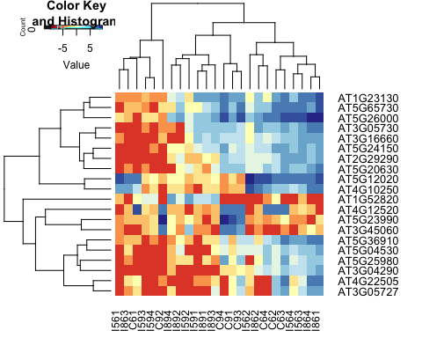

Visulize pathway enrichment results using bioconductor package "pathview"
library(pathview)
DE.paths <- read.table(file="https://raw.githubusercontent.com/ucdavis-bioinformatics-training/2017-June-RNA-Seq-Workshop/master/friday/Figures/I5_v_C_time6_KEGG.txt", sep="\t", header=T, stringsAsFactors=F)
head(DE.paths, 1)
## pathway.code pathway.name p.value
## 1 ath03010 Ribosome - Arabidopsis thaliana (thale cress) 5.378589e-35
## Annotated
## 1 301
pid <- DE.paths$pathway.code[3]
DE.expr <- read.table(file="https://raw.githubusercontent.com/ucdavis-bioinformatics-training/2017-June-RNA-Seq-Workshop/master/friday/Figures/I5_v_C_time6.txt", sep="\t", header=T, stringsAsFactors=F)
head(DE.expr, 2)
## Gene logFC AveExpr P.Value adj.P.Val
## 1 AT4G12520 -10.254556 0.3581132 2.206726e-10 4.651998e-06
## 2 AT3G30720 5.817438 3.3950689 9.108689e-10 9.601014e-06
rownames(DE.expr) <- DE.expr$Gene
colnames(DE.expr)
## [1] "Gene" "logFC" "AveExpr" "P.Value" "adj.P.Val"
gene.data <- subset(DE.expr, select="logFC")
head(gene.data)
## logFC
## AT4G12520 -10.254556
## AT3G30720 5.817438
## AT5G26270 2.421030
## AT3G33528 -4.780814
## AT1G64795 -4.872595
## AT3G05955 -4.158939
pv.out <- pathview(gene.data=gene.data, pathway.id=pid, species="ath", gene.idtype="KEGG", kegg.native=T)
## Info: Working in directory /Users/jli/Jessie/Research/BioInfo/presentation/Figure
## Info: Writing image file ath04141.pathview.png
By default, running pathview() will create an image file named by the pathway id (for example, in this case there should be a file named "ath04141.pathview.png" in the current directory).
Another a package for ploting is "piano". It generates network style graphs. "Cytoscape" is another possible software to generate graphs for enrichment analysis results.

Visulize GO enrichment results use revigo.irb.hr web application
In a web browser (Safari, explorer, chrome, firefox), open revigo.irb.hr.

